# UNO Coin *Install Guide*

**Integration Document**

*Version 1.0.1*

**Overview**

Unochat provides the recharging interface(UNOcoin Exchanger) to facilitate the vending of the UNOcoin.

This document should be forwarded by the UNOcoin Exchanger owner to their developer who will be install a system with the UNOcoin Exchanger.

It has been written about the way how to install the UNOcoin Exchanger on Ubuntu 14.04 LTS 64bit.

**Install MongoDB**

MongoDB is a NoSQL database intended for storing large amounts of data in document-oriented storage with dynamic schemas.

NoSQL refers to a database with a data model other than the tabular format used in relational databases such as MySQL, PostgreSQL, and Microsoft SQL.

MongoDB features include: full index support, replication, high availability, and auto-sharding.

**Step #1: Setup a the Package Database**

First we’ll import the MongoDB public key used by the package management system:

sudo apt-key adv --keyserver hkp://keyserver.ubuntu.com:80 --recv 7F0CEB10

Then we’ll create a list file for MongoDB:

echo 'deb http://downloads-distro.mongodb.org/repo/ubuntu-upstart dist 10gen' | sudo tee /etc/apt/sources.list.d/mongodb.list

Now reload the package database:

sudo apt-get update

**Step #2: Install Latest Stable Version MongoDB**

At this point, installing MongoDB is as simple as running just one command:

sudo apt-get install -y mongodb-org

If you’d like MongoDB to auto-update with apt-get than you’re done with the installation. But, it’s possible to ‘pin’ the version of MongoDB you just installed to prevent apt-get from auto-updating.

echo "mongodb-org hold" | sudo dpkg --set-selections  
echo "mongodb-org-server hold" | sudo dpkg --set-selections  
echo "mongodb-org-shell hold" | sudo dpkg --set-selections  
echo "mongodb-org-mongos hold" | sudo dpkg --set-selections  
echo "mongodb-org-tools hold" | sudo dpkg --set-selections

**Step #3: Get MongoDB Running**

Start-Up MongoDB

sudo service mongod start

Check MongoDB Service Status

sudo service mongod status

Summary List of Status Statistics (Continuous)

mongostat

Enter the MongoDB Command Line

Mongo

By default, running this command will look for a MongoDB server listening on port 27017 on the localhost interface.

If you’d like to connect to a MongoDB server running on a different port, then use the –port option. For example, if you wanted to connect to a local MongoDB server listening on port 22222, then you’d issue the following command:

mongo --port 22222

Shutdown MongoDB

sudo service mongod stop

**Install LAMP**

**Introduction**

The LAMP stack (Linux, Apache, MySQL, PHP) is a group of open source software that is typically installed together to enable a server to host dynamic PHP websites and web apps. This section includes the steps to set up a LAMP stack on Ubuntu 14.04, on a single server, so you can quickly get UNOcoin Exchanger application up and running.

## Step #1: Update apt-get package lists

sudo apt-get update

## Step #2: Install Apache, MySQL, and PHP packages

sudo apt-get install –y apache2 mysql-server php5-mysql php5 libapache2-mod-php5 php5-mcrypt

When prompted, set and confirm a new password for the MySQL "root" user:

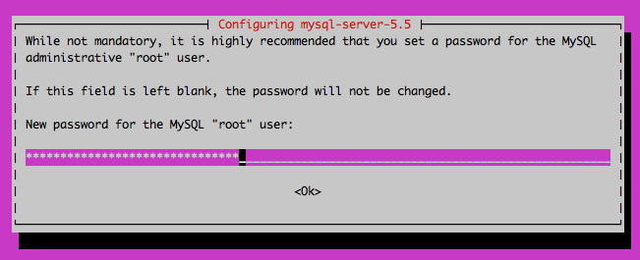

## Step #3: Create MySQL database directory structure

sudo mysql_install_db

## Step #4: Run basic MySQL security script

sudo mysql_secure_installation

**Install MongoDB for PHP**

**Step #1**

To get this thing going, we’ll need to resolve some dependencies. To do that, run this command from the terminal.

sudo apt-get install php-pear php5-dev

**Step #2**

You should easily be able to install the driver with the following command.

sudo pecl install mongo

**Step #3**

What makes Ubuntu 14.04 a little different from other systems in how PHP extensions get loading when Apache/PHP starts.

To make sure this extension gets loaded, we’ll need to add a .ini file to “/etc/php5/conf.d”.

To do that, run the following command:

sudo touch /etc/php5/apache2/conf.d/mongo.ini

After creating the file, add this line of content.

extension=mongo.so

After you’ve saved your new .ini file, restart Apache and verify that the extension is loading with phpinfo().

**Import UNOcoin tables for MongoDB**

We have provide Unocoin database table architecture with BSON files.

You can find that files from sql/mongo directory of our git repository.

**Step #1**

Copy the BSON files to your server directory via FTP etc.

**Step #2**

You've expected the database named “unochat” on the server.

You need to import BSON file in server using mongorestore command.

mongorestore –d unochat [path of BSON directory]

After you can check imported tables in mongodb using bellow commands.

# mongo

> use unochat

Switched to db unochat

> show tables

groups

system.indexes

users

**Install UNOcoin Exchanger**

**Step #1: Copy the sources of application to server**

We’ve provide all of the source of application via github.

You can download(or clone) the source from bellow github repository.

<https://github.com/zongyii/Unocoin>

After You’ve to copy the source to your server.

Unocoin/backend/unocoin

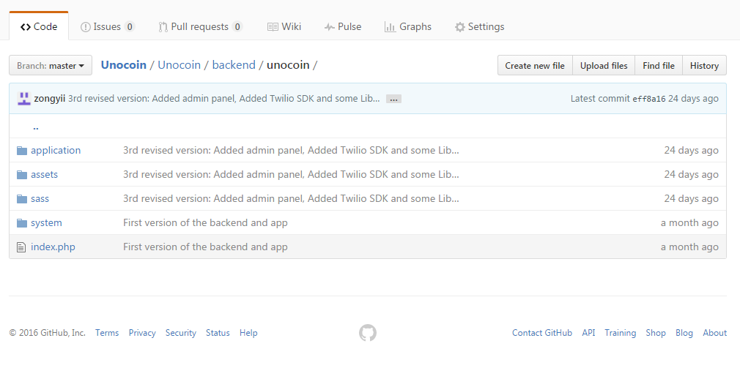

**Step #2: Change configuration**

When finished to copy the source, You have to change some configurations.

* ./application/config/unochat.php

$config['unochat_app_key'] = '';

$config['unochat_app_secret'] = '';

Please put your app key and app secret these are to get from unochat merchant dashboard.

* ./application/config/twilio.php

$config['account_sid'] = '';

$config['auth_token'] = '';

$config['from_phone_number'] = "";

Please put your twilio account SID/authentication token/phone number these are to get from Twilio.

* ./application/config/stripe.php

$config['stripe_mode'] = TRUE; // dev: FALSE, live: TRUE

$config['stripe_dev_public_key'] = '';

$config['stripe_live_public_key'] = '';

$config['stripe_dev_secret_key'] = '';

$config['stripe_live_secret_key'] = '';

Please put Stripe credentials these are to get from Stripe

* ./application/config/mongo_db.php

$config['mongo_db']['active'] = 'default';

$config['mongo_db']['default']['no_auth'] = FALSE;

$config['mongo_db']['default']['hostname'] = 'localhost';

$config['mongo_db']['default']['port'] = '27017';

$config['mongo_db']['default']['username'] = 'root';

$config['mongo_db']['default']['password'] = '';

$config['mongo_db']['default']['database'] = 'unochat';

$config['mongo_db']['default']['db_debug'] = TRUE;

$config['mongo_db']['default']['return_as'] = 'array';

$config['mongo_db']['default']['write_concerns'] = (int)1;

$config['mongo_db']['default']['journal'] = TRUE;

$config['mongo_db']['default']['read_preference'] = NULL;

$config['mongo_db']['default']['read_preference_tags'] = NULL;

$config['mongo_db']['default']['no_auth'] = FALSE;

$config['mongo_db']['test']['hostname'] = 'localhost';

$config['mongo_db']['test']['port'] = '27017';

$config['mongo_db']['test']['username'] = 'root';

$config['mongo_db']['test']['password'] = '';

$config['mongo_db']['test']['database'] = 'unochat';

$config['mongo_db']['test']['db_debug'] = TRUE;

$config['mongo_db']['test']['return_as'] = 'array';

$config['mongo_db']['test']['write_concerns'] = (int)1;

$config['mongo_db']['test']['journal'] = TRUE;

$config['mongo_db']['test']['read_preference'] = NULL;

$config['mongo_db']['test']['read_preference_tags'] = NULL;

You can check mongoDB settings and put the information such as username, password, port etc.

**Step #3: Get Dashboard Running**

You can check application dashboard when you finished to install.

http(s)://Your-Server-IP-Address-Or-Domain-Name/index.php/admin/login

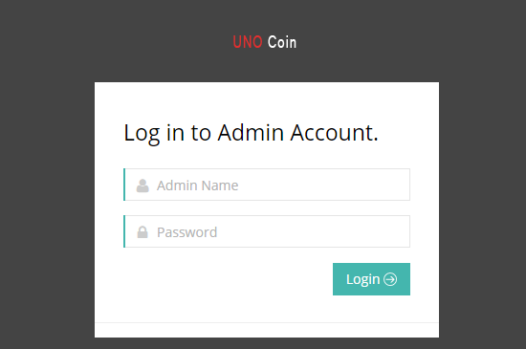

Admin Name: admin

Password: password

Then you can see main dashboard page like bellow.

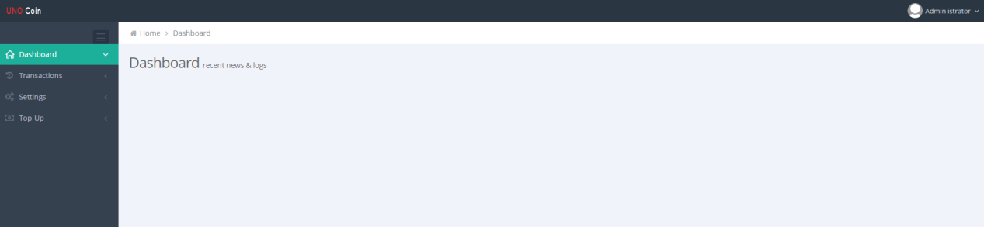

So you can put the menu url at Unochat Merchant Dashboard like:

http(s)://Your-Server-IP-Address-Or-Domain-Name/index.php/dashboard

**Success !!**